EATALY: Intelligent Campus Food Management with Demand Forecasting

A PROJECT REPORT

Submitted by

AISHWARYA B LATHA A
– 241701003
– 241701024

In fulfilment for the course

GE23627 – DESIGN THINKING AND INNOVATION
for the degree of

BACHELOR OF ENGINEERING IN COMPUTER SCIENCE AND DESIGN



RAJALAKSHMI ENGINEERING COLLEGE THANDALAM, CHENNAI
OCTOBER 2026

RAJALAKSHMI ENGINEERING COLLEGE THANDALAM, CHENNAI

BONAFIDE CERTIFICATE

Certified that this Report titled “EATALY: Intelligent Campus Food Management with Demand Forecasting” is the bonafide work of AISHWARYA B (241701003) and LATHA A (241701024), who carried out the work under my supervision. Certified further that to the best of my knowledge, the work reported herein does not form part of any other thesis or dissertation on the basis of which a degree or award was conferred on an earlier occasion on these or any other candidates.

Certified further that this project directly contributes to the United Nations Sustainable Development Goals: SDG 2 (Zero Hunger), SDG 9 (Industry, Innovation, and Infrastructure), and SDG 12 (Responsible Consumption and Production) by preventing collegiate food wastage, decentralizing crowd kinematics, and providing localized accessible computing architectures.

SIGNATURE OF HOD
Dr. S. Vinodh Kumar Professor, The Head of the Department
Computer Science and Design Rajalakshmi Engineering College Chennai – 602105

SIGNATURE OF SUPERVISOR
Dr. P. Revathy Professor

Computer Science and Design Rajalakshmi Engineering College Chennai – 602105

ABSTRACT

Campus food services often experience long waiting times, uneven customer distribution across canteens, inaccurate demand estimation, and inefficient order management, leading to student inconvenience, food wastage, and increased operational burden. Traditional food ordering systems primarily focus on digital payments and online ordering but lack intelligent mechanisms for real-time congestion management, demand prediction, and decentralized decision-making. EATALY addresses these challenges through a decentralized campus food management ecosystem that integrates load-aware routing, capacity-bounded scheduling, and on-device demand forecasting to optimize food ordering and distribution across multiple campus canteens. The proposed system consists of a student mobile application, an administrative dashboard, and a cloud-based backend that work together to provide seamless order placement, real-time queue monitoring, and efficient kitchen management. EATALY dynamically recommends the least congested canteen using a load-balancing algorithm, allocates pickup slots based on kitchen capacity, and employs lightweight machine learning models to forecast food demand from historical ordering patterns and temporal trends. The platform also incorporates inventory monitoring, digital token generation, secure user authentication, multilingual support, and offline synchronization to ensure reliable operation even under intermittent network connectivity. A user-centric interface designed through the Design Thinking methodology enhances accessibility and simplifies interactions for students, faculty, and canteen administrators. The proposed architecture is scalable, modular, and suitable for deployment across educational institutions with multiple food outlets. By intelligently distributing customer demand, minimizing queue congestion, improving resource utilization, and enabling data-driven operational decisions, EATALY aims to transform conventional campus dining into a smart, efficient, and sustainable food management ecosystem while significantly enhancing the overall user experience.

ACKNOWLEDGEMENT

Initially, we thank the Almighty for being with us through every walk of our lives and showering His blessings throughout the endeavour to complete this report. Our sincere thanks to our Chairman Mr. S. Meganathan, B.E., F.I.E., our Vice Chairman Mr. Abhay Shankar Meganathan, B.E., M.S., and our respected Chairperson Dr. (Mrs.) Thangam Meganathan, Ph.D., for providing us with the requisite infrastructure and facilities at their esteemed institution.

Our sincere thanks to Dr. S. N. Murugesan, M.E., Ph.D., our beloved Principal, for his kind support and the facilities provided to complete our project work successfully. We express our sincere thanks to Dr. S. Vinodh Kumar, Ph.D., Professor and Head of the Department of Computer Science and Design, for his valuable guidance and encouragement throughout the project. We convey our heartfelt gratitude to our internal project guide, Dr. P. Revathy, Professor, Department of Computer Science and Design, for her continuous guidance, constructive suggestions and valuable support during the development of our project. We also thank the faculty members, our families and friends for their encouragement and support.

AISHWARYA B (241701003)
LATHA A (241701024)

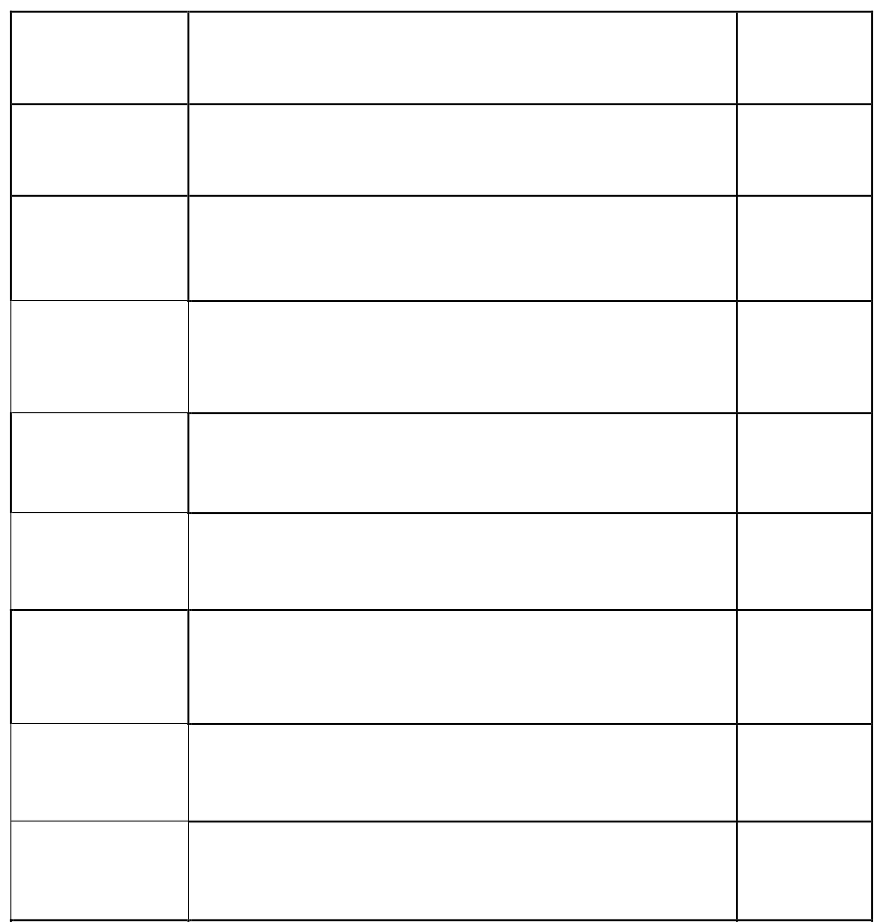
TABLE OF CONTENTS
4
SOFTWARE IMPLEMENTATION
29
5
METHODOLOGY AND ALGORITHMS
37
6
TESTING AND RESULTS
42
7
CONCLUSION AND FUTURE SCOPE
47
8
REFERENCES
48

S.NO | TITLE | PAGE.NO
1 | INTRODUCTION | 7
2 | LITERATURE SURVEY | 13
3 | SYSTEM DESIGN | 18

LIST OF FIGURES

FIGURE NO. | TITLE | PAGE.NO
3.1 | Overall system architecture of EATALY | 21
3.2 | Overall system flow diagram | 22
3.3 | Use case diagram of EATALY | 23

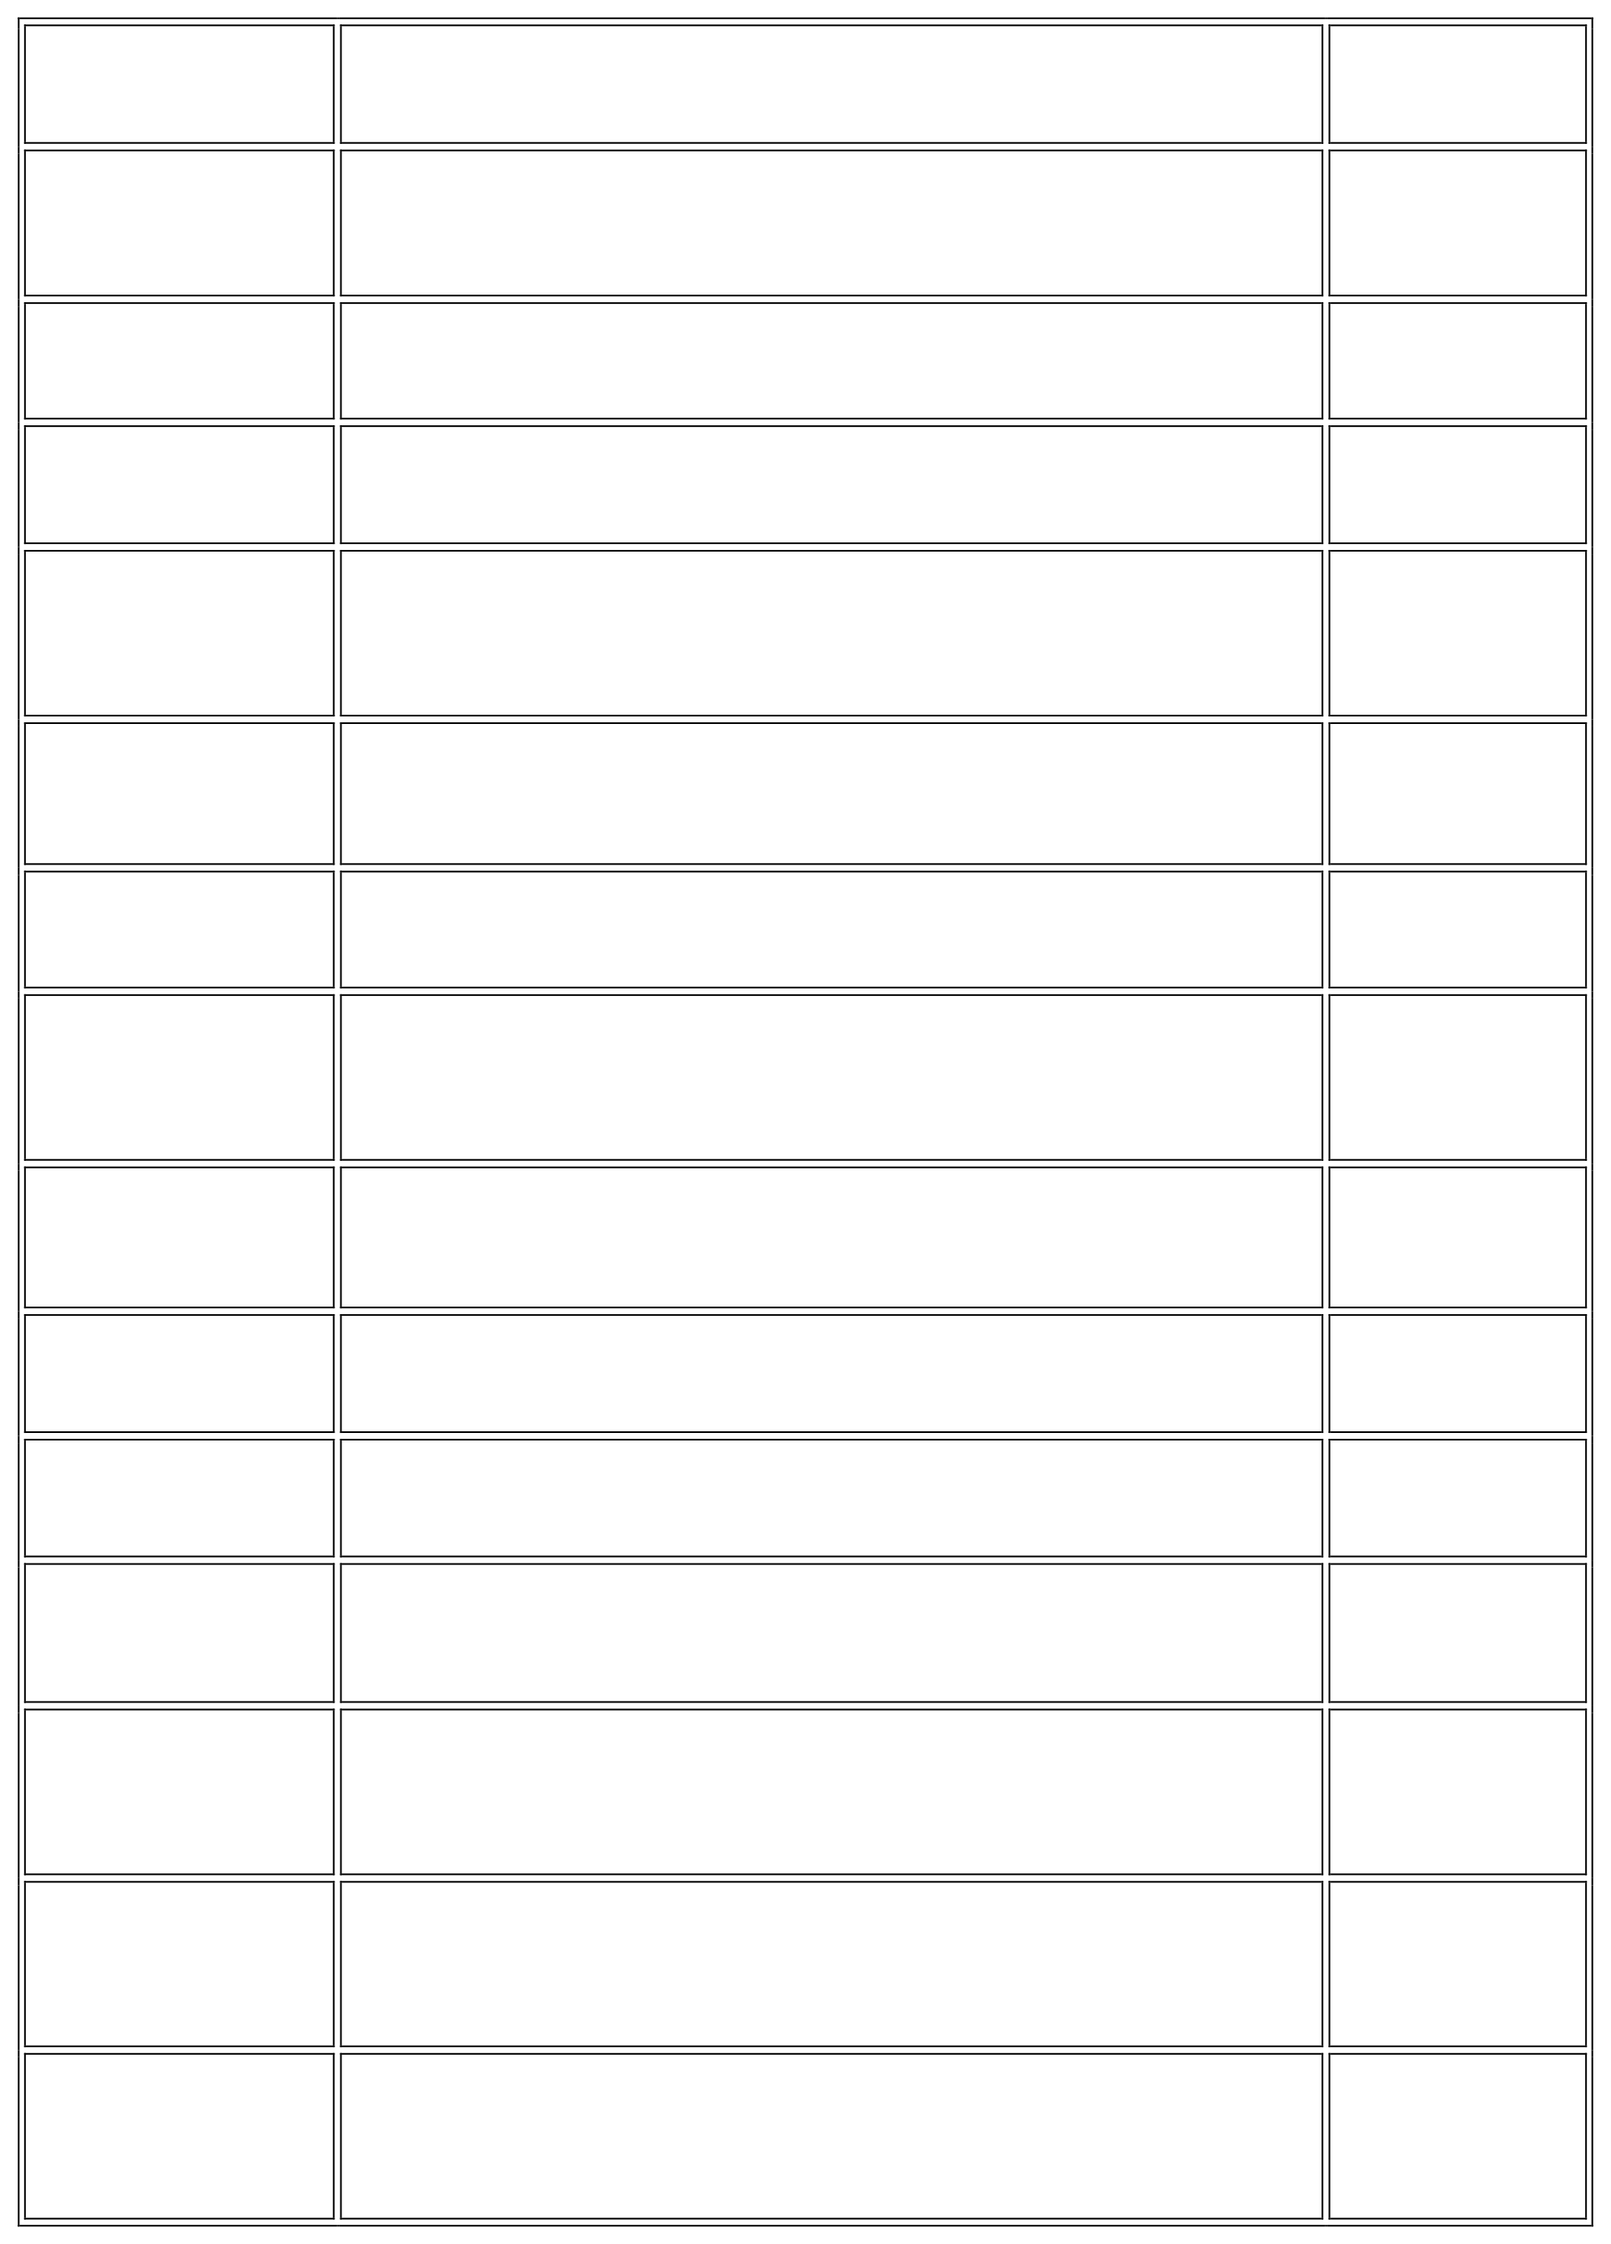
3.4

3.5

3.6

4.1

4.2

4.3

4.4

4.5

6.1

6.2

6.3
Activity diagram for the EATALY order 25
workflow
Sequence diagram for EATALY order workflow 26
Data-flow diagram 27
EATALY student apllication home screen 30
EATALY staff and administration portal with
bilingual support (English and Tamil) 32
Smart Load Balancing and Crowd Management 33
Payment and Pickup slot management 35
Real time order tracking 36
EATALY testing and evaluation workflow 43
Comparison of average waiting time per canteen
45
between conventional operation and EATALY
Order Completion during peak hours 45

INTRODUCTION

General
Campus food services play a vital role in supporting the daily activities of students, faculty members, and staff within educational institutions. However, managing food ordering and distribution efficiently remains a significant challenge due to increasing student populations, limited serving capacity, and concentrated demand during peak hours. Conventional canteen operations primarily rely on manual ordering, physical queues, or basic digital ordering systems, which often lead to prolonged waiting times, uneven customer distribution, inaccurate demand estimation, and inefficient utilization of kitchen resources.
EATALY addresses these challenges by providing a smart campus food management ecosystem that integrates digital ordering, intelligent scheduling, load-aware routing, and demand forecasting to improve operational efficiency and enhance the overall dining experience.

Background
The increasing adoption of digital technologies has transformed various services within educational institutions, including food ordering and campus management. However, many college canteens continue to rely on conventional ordering methods or basic online systems that primarily support menu browsing and payment processing. These systems often lack intelligent mechanisms to manage customer flow, predict food demand, or optimize kitchen operations, resulting in congestion during peak hours and inefficient utilization of available resources.
Recent advancements in cloud computing, mobile applications, and data analytics

have enabled the development of smart service ecosystems capable of processing real-time information and supporting informed decision-making. By integrating these technologies, EATALY improves operational efficiency, enhance user convenience, and reduce food wastage.

Problem Statement
Managing food services in educational institutions is challenging due to increasing student populations, limited serving capacity, and concentrated demand during break and lunch hours. Conventional canteen operations often lead to long waiting queues, uneven customer distribution, inaccurate demand estimation, and inefficient kitchen scheduling. Existing digital ordering systems primarily focus on order placement and payment processing, offering limited support for congestion management, resource optimization, and operational planning.
Furthermore, students frequently experience uncertainty regarding queue lengths, food availability, and preparation time, while administrators struggle to efficiently allocate resources and minimize food wastage. These challenges highlight the need for an integrated food management ecosystem that combines intelligent scheduling, real-time monitoring, load-aware routing, and predictive demand analytics to improve operational efficiency and deliver a seamless campus dining experience.

Motivation
The motivation behind the Eataly project is to simplify campus food ordering by reducing long queues and waiting time, providing students with a convenient and efficient digital ordering experience.
Eataly aims to address these issues by developing a centralized food ordering and cafeteria management application that connects students with campus cafeteria services. The application enables students to browse menus, view food item details and prices, place orders digitally, and track their order status. By reducing dependence on manual ordering and improving access to information, the system seeks to enhance the overall food ordering experience.

Eataly seeks to bridge the gap between students and campus cafeteria services through technology, creating a smarter, more convenient, and more efficient campus dining experience

Objectives
The primary objective of EATALY is to develop a smart campus food management ecosystem that improves operational efficiency, reduces waiting time, and enhances the overall dining experience through intelligent scheduling and data-driven decision making.
The specific objectives are:

- To develop a mobile-based platform for seamless campus food ordering and digital payment.
- To implement intelligent load-aware routing for balanced customer distribution across multiple canteens.
- To design a capacity-based pickup scheduling mechanism that minimizes queue congestion.
- To predict food demand using historical ordering patterns to assist inventory planning.
- To provide administrators with real-time analytics for monitoring orders, sales, and resource utilization.
- To reduce food wastage and improve kitchen efficiency through data-driven operational management.
- To enhance user satisfaction by providing a fast, convenient, and reliable food ordering experience.

Scope and Limitations

The scope of EATALY includes the development of a smart campus food management ecosystem comprising a student mobile application, an administrative dashboard, and a cloud-based backend infrastructure. The system supports digital food ordering, secure user authentication, real-time menu management, intelligent canteen recommendation, capacity-based pickup scheduling, demand forecasting, and administrative analytics. It is designed to facilitate efficient food service operations

across multiple campus canteens while improving user convenience and operational decision-making.

The proposed system is intended for deployment within educational institutions and assumes the availability of internet connectivity and digital infrastructure. The current implementation is limited to campus food services and does not support external food delivery or third-party restaurant integration. Demand forecasting accuracy depends on the availability of historical order data, while real-time recommendations rely on timely updates from participating canteens.

Existing System

Existing campus food ordering systems primarily provide basic functionalities such as digital menu browsing, online order placement, and payment processing. While these systems improve accessibility and reduce manual transactions, they generally operate independently without considering real-time congestion, kitchen workload, or customer distribution. As a result, students continue to experience long waiting times during peak hours despite the availability of online ordering facilities.
Traditional canteen operations largely depend on manual queue management and first-come-first-served service models, which often lead to overcrowding, inefficient resource utilization, and inaccurate demand estimation. Administrators also have limited access to analytical tools for monitoring food demand, inventory consumption, and operational performance. These limitations highlight the need for an integrated and intelligent campus food management ecosystem capable of optimizing food ordering, resource allocation, and overall dining efficiency.

Limitations of Existing Approaches

Conventional campus food ordering systems are primarily designed to facilitate digital transactions and online order placement, but they often lack intelligent mechanisms for managing real-time congestion, optimizing kitchen workloads, and predicting customer demand. Manual queue management and first-come-first-served service

models continue to dominate many educational institutions, resulting in prolonged waiting times, uneven customer distribution, and inefficient utilization of available resources.
Furthermore, existing systems generally operate as standalone applications without providing integrated analytics for inventory management, demand forecasting, or operational planning. Students have limited visibility into queue conditions and food availability, while administrators struggle to make informed decisions based on real-time data.

Proposed EATALY System

EATALY consists of three interconnected components: a student mobile application, an administrative dashboard, and a cloud-based backend infrastructure. The mobile application enables users to browse menus, place food orders, complete digital payments, and receive real-time updates on order status and pickup schedules. The administrative dashboard provides tools for menu management, order monitoring, inventory planning, sales analytics, and operational reporting, enabling canteen administrators to efficiently manage daily food service activities.
The system incorporates intelligent features such as load-aware canteen recommendation, capacity-based pickup scheduling, and demand forecasting using historical ordering data. Real-time synchronization ensures seamless communication between students, kitchen staff, and administrators, while secure authentication protects user information. By integrating these technologies into a unified platform, EATALY establishes a smart campus food management ecosystem that enhances operational efficiency, minimizes waiting time, reduces food wastage, and significantly improves the overall dining experience.

Advantages and Applications

The primary advantage of EATALY is its ability to integrate intelligent food ordering, queue management, demand forecasting, and administrative analytics into a single campus food management ecosystem. The platform minimizes waiting

time through load-aware canteen recommendation and capacity-based pickup scheduling, while real-time monitoring improves operational efficiency and enhances the overall user experience. Predictive demand analysis further assists administrators in optimizing inventory management, reducing food wastage, and improving resource utilization.

EATALY has potential applications in universities, colleges, corporate campuses, hospitals, and other institutions that operate multiple food outlets. The system enables students and staff to conveniently order food, monitor queue conditions, and collect meals efficiently through a digital platform. Administrators can utilize analytical insights to support decision-making, monitor operational performance, and improve service quality. Although the current implementation is focused on campus food services, the proposed architecture is scalable and can be extended to larger food service environments with advanced analytics, IoT-based inventory monitoring, and AI-driven operational optimization.

LITERATURE SURVEY

Introduction

Digital technologies have significantly improved food ordering and management systems by enabling online ordering, cashless payments, and real-time communication. However, many campus food services still experience long waiting times, inefficient queue management, and poor demand estimation during peak hours. Existing systems mainly focus on order placement and payment while offering limited support for intelligent scheduling and operational optimization.

This literature survey reviews research on smart food ordering systems, queue management, demand forecasting, and cloud-based campus applications. The study provides the theoretical foundation for developing EATALY, an intelligent campus food management ecosystem that integrates digital ordering, load-aware routing, and predictive analytics.

Review of Related Research

Recent research has focused on developing mobile and cloud-based food ordering systems to improve convenience and reduce manual operations. These systems allow users to browse menus, place orders, and make digital payments, but many lack intelligent features for managing congestion and optimizing kitchen operations.

Researchers have also explored queue management, load balancing, and demand forecasting techniques to improve service efficiency. Predictive analytics using historical order data helps estimate food demand, reduce wastage, and improve inventory planning. These studies provide the foundation for EATALY, which combines intelligent scheduling, real-time monitoring, and demand forecasting into a unified campus food management ecosystem.

In recent years, smart campus initiatives have encouraged the integration of cloud computing, mobile applications, and data analytics to enhance institutional services. These technologies enable real-time monitoring, efficient resource allocation, and informed decision-making across various campus operations. EATALY builds upon these advancements by providing an integrated platform that connects students, canteen administrators, and kitchen staff, ensuring efficient food service management while improving user satisfaction and operational performance.

Existing Campus Food Management Systems

Existing campus food management systems primarily focus on digitizing food ordering through mobile or web applications. These platforms allow users to browse menus, place orders, and complete online payments, improving convenience and reducing manual transactions. However, most systems provide limited support for intelligent decision-making and operational optimization.

Many institutions continue to rely on manual queue management and first-come-first-served service models, leading to overcrowding during peak hours and inefficient utilization of kitchen resources. Existing applications generally do not provide real-time queue monitoring, balanced canteen allocation, or intelligent pickup scheduling, resulting in prolonged waiting times and inconsistent service quality.

Recent smart food management solutions have begun integrating cloud computing, real-time analytics, and demand forecasting to improve operational efficiency. EATALY builds upon these technologies by combining digital ordering, load-aware routing, capacity-based scheduling, and predictive analytics into a unified ecosystem, providing a more efficient and user-centric approach to campus food management.

Intelligent Food Management and Scheduling Methods

Modern campus food management systems employ digital technologies to improve ordering efficiency, reduce waiting time, and streamline canteen operations. Mobile applications, cloud computing, and real-time databases enable users to place orders, track order status, and receive instant notifications. These technologies provide greater convenience while minimizing manual intervention in the ordering process.

Queue management and scheduling techniques play a crucial role in improving service efficiency during peak hours. Intelligent scheduling allocates pickup slots based on kitchen capacity, while load-balancing methods distribute customers across multiple food outlets to prevent overcrowding. Demand forecasting techniques further assist administrators in predicting food consumption patterns, enabling better inventory planning and reducing food wastage.

EATALY integrates these intelligent technologies into a unified campus food management ecosystem. The system combines digital food ordering, load-aware canteen recommendation, capacity-based pickup scheduling, and predictive analytics to optimize operational efficiency while providing students with a faster, more convenient, and reliable dining experience.

Existing Smart Food Ordering Platforms

Several commercial food ordering platforms have transformed the way customers order and receive food through digital applications. Swiggy and Zomato provide features such as online menu browsing, digital payments, real-time order tracking, and customer reviews. These platforms are designed for restaurant food delivery and primarily focus on connecting customers with restaurants rather than managing institutional food services.

Educational institutions have also introduced campus-specific food ordering applications that allow students to pre-order meals and collect them using digital tokens. While these systems reduce manual ordering, most do not provide intelligent canteen recommendation, demand forecasting, or real-time load balancing. They generally operate on a first-come-first-served basis and offer limited analytical support for administrators.

These existing solutions demonstrate the effectiveness of digital food ordering but reveal significant gaps in operational intelligence. EATALY addresses these limitations by integrating load-aware routing, capacity-based pickup scheduling, demand forecasting, and administrative analytics into a unified campus food management ecosystem, enabling more efficient resource utilization and an improved dining experience.

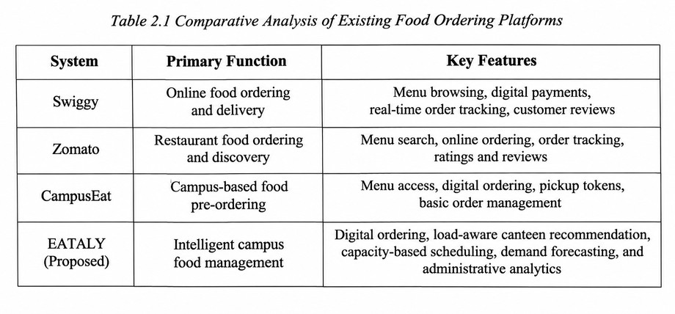

Comparative Analysis

Existing food ordering platforms provide various features depending on their intended applications. Commercial platforms such as Swiggy and Zomato primarily

ocus on restaurant discovery, online ordering, and food delivery, while campus-based systems emphasize digital ordering and token generation. Although these solutions improve user convenience, they generally provide limited support for intelligent resource allocation and operational optimization.

EATALY combines the strengths of existing digital food ordering systems with intelligent scheduling and predictive analytics. The proposed system integrates load-aware canteen recommendation, capacity-based pickup scheduling, demand forecasting, and administrative analytics within a unified platform. This integration enables efficient resource utilization while improving the overall campus dining experience.

The primary contribution of EATALY is the development of a smart campus food management ecosystem that extends beyond conventional food ordering by incorporating real-time decision support and data-driven operational management.

Research Gap

Existing research and commercial food ordering systems primarily focus on digital ordering, payment processing, and order tracking. However, limited attention has been given to intelligent canteen recommendation, real-time queue optimization, capacity-based scheduling, and predictive demand analysis within educational institutions. As a result, campuses continue to experience overcrowding, inefficient resource utilization, and food wastage during peak hours.

EATALY addresses these limitations by developing an integrated campus food management ecosystem that combines digital ordering, intelligent scheduling, load-aware routing, and demand forecasting within a single platform. The proposed approach aims to improve operational efficiency, reduce waiting time, and support data-driven decision-making for campus food service management.

SYSTEM DESIGN

General

System design defines the overall architecture, components, and communication flow required for developing an intelligent campus food management ecosystem. EATALY consists of three interconnected components: the student mobile application, the administrative dashboard, and a cloud-based backend infrastructure. The student application enables users to browse menus, place food orders, make digital payments, and receive real-time order updates. The administrative dashboard allows canteen staff to manage menus, monitor orders, analyze sales, and oversee daily operations. The cloud backend synchronizes data between all system components while supporting secure authentication, real-time database updates, and intelligent decision-making. Features such as load-aware canteen recommendation, capacity-based pickup scheduling, and demand forecasting work together to optimize food service operations, improve resource utilization, and enhance the overall campus dining experience.

Requirement Analysis

The primary requirement of EATALY is to provide an integrated digital platform that simplifies campus food ordering while improving operational efficiency for canteen administrators. The system must support user authentication, menu management, online food ordering, secure payment processing, real-time order tracking, and notification services. It should also facilitate communication between students, kitchen staff, and administrators through a centralized cloud infrastructure. In addition to these functional requirements, the system should provide intelligent features such as load-aware canteen recommendation, capacity-based pickup scheduling, demand forecasting, and administrative analytics. Non-functional requirements include reliability, scalability, security, usability, and real-time performance to ensure seamless operation across multiple campus food outlets and a consistent user experience.

Functional and Non-Functional Requirements

The requirements of EATALY are categorized into functional and non-functional requirements to ensure that the proposed system satisfies both operational needs and quality attributes necessary for efficient campus food management.

Functional Requirements

The EATALY system must provide secure user authentication for students and administrators through a centralized login mechanism. Students should be able to browse food menus, place orders, make digital payments, track order status, and receive notifications regarding order confirmation and pickup schedules. The system must also recommend suitable canteens based on real-time congestion levels and support capacity-based pickup scheduling to reduce waiting time.

The administrative dashboard should enable menu management, order monitoring, inventory tracking, sales reporting, and user management. The system must support real-time synchronization between students, kitchen staff, and administrators through a cloud database. Additionally, it should implement demand forecasting using historical ordering data and generate analytical reports to assist administrators in operational planning and resource allocation.

Non-Functional Requirements

The non-functional requirements emphasize reliability, security, scalability, usability, and performance. The application should provide an intuitive user interface with responsive navigation across supported mobile devices. All user information, orders,

and payment details must be securely stored and transmitted using appropriate authentication and cloud security mechanisms.

The system should maintain real-time synchronization with minimal response time while supporting multiple users simultaneously during peak ordering hours. It must be scalable to accommodate additional campus canteens and increasing user demand. Furthermore, the modular system architecture should facilitate maintenance, future enhancements, and seamless integration of advanced features such as machine learning–based demand prediction and IoT-enabled inventory monitoring.

Overall System Architecture

EATALY follows a cloud-based client–server architecture consisting of a student mobile application, an administrative dashboard, and a centralized backend database. Students use the mobile application to browse menus, place food orders, complete digital payments, and receive real-time updates on order status and pickup schedules. The backend processes user requests, stores transaction data, and synchronizes information between students, kitchen staff, and administrators through a secure cloud infrastructure.

The system incorporates intelligent modules for load-aware canteen recommendation, capacity-based pickup scheduling, and demand forecasting to improve operational efficiency. The administrative dashboard enables menu management, order monitoring, inventory planning, and sales analysis through a centralized interface. This architecture ensures seamless communication among all system components while supporting real-time data synchronization, secure authentication, and scalable deployment across multiple campus food outlets.

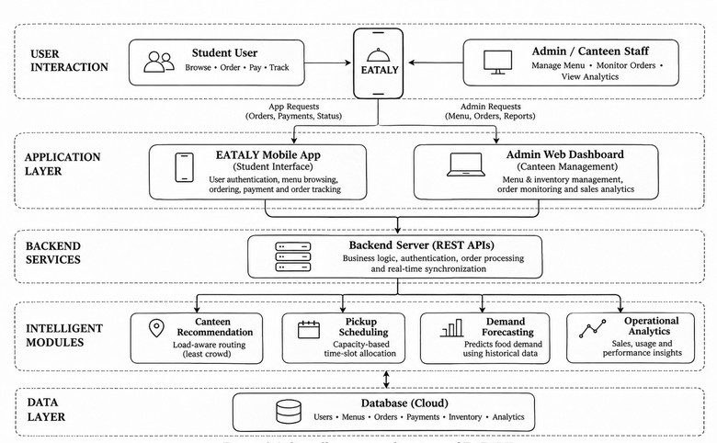

Figure 3.1 Overall system architecture of EATALY

System Flow Diagram

The EATALY workflow begins when a student logs into the mobile application and browses the available food menu. The user selects the desired food items, places an order, and completes the payment through the application. The order request is then transmitted to the cloud backend, where it is authenticated, processed, and assigned to the appropriate campus canteen based on availability and operational conditions.

The backend performs load-aware canteen recommendation, capacity-based pickup scheduling, and demand analysis before forwarding the order to the selected kitchen. Canteen staff receive the order through the administrative dashboard, prepare the requested items, and update the order status in real time. Students receive notifications regarding order confirmation, preparation progress, and pickup schedules through the

mobile application. Administrative functions such as menu management, sales monitoring, inventory tracking, and operational analytics are continuously synchronized with the cloud database, ensuring efficient coordination among students, kitchen staff, and canteen administrators.

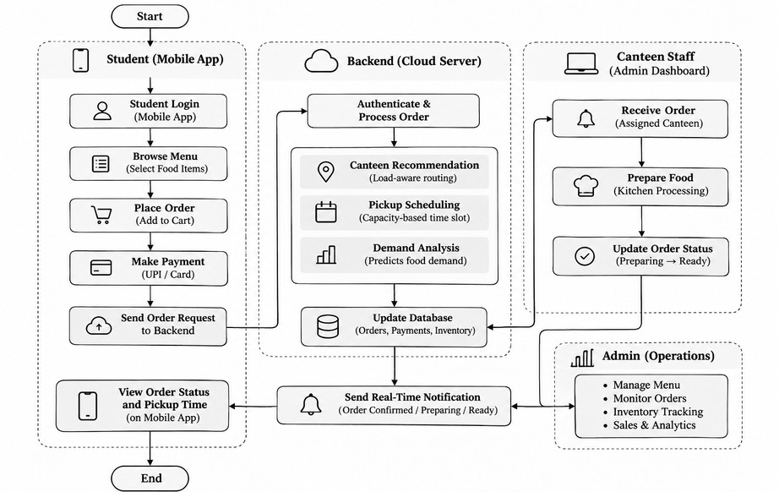

Figure 3.2 Overall system flow diagram

Use Case Diagram

The use case diagram illustrates the interactions between the students, canteen administrators, and the EATALY system. Through the mobile application, students can register or log in, browse food menus, place orders, make digital payments, track order status, receive notifications, and collect food at the scheduled pickup time. These interactions enable a seamless and convenient food ordering experience within the campus environment.

The administrative dashboard allows canteen staff to manage menus, process incoming orders, update preparation status, monitor inventory, and generate sales reports. The cloud backend coordinates communication between all system components while supporting load-aware canteen recommendation, capacity-based pickup scheduling, demand forecasting, and real-time synchronization. The use case diagram groups these interactions within the EATALY system boundary, illustrating the relationship between users and the intelligent campus food management ecosystem.

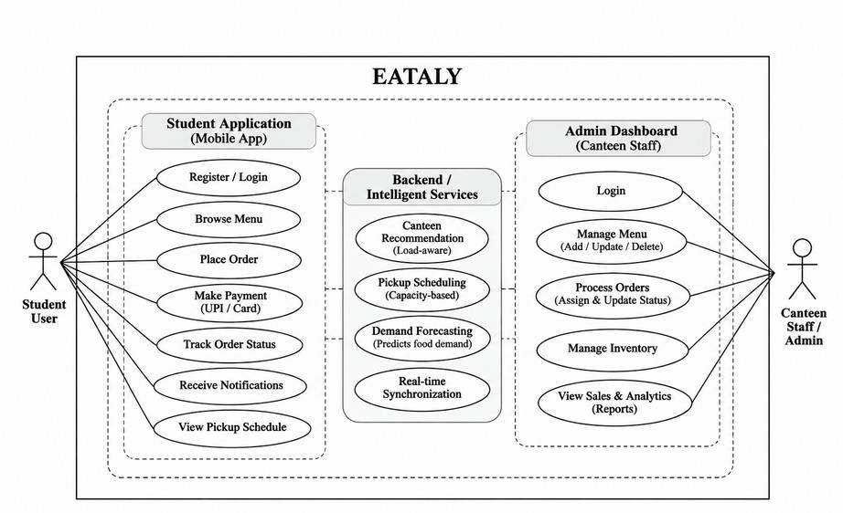

Figure 3.3 Use case diagram of EATALY

Activity and Sequence Diagrams

The activity and sequence diagrams illustrate the operational workflow and communication among the student application, cloud backend, and administrative dashboard within the EATALY system. The activity diagram represents the

sequence of actions involved in placing and processing food orders, while the sequence diagram describes how information is exchanged between students, administrators, and the backend services during system operation.

Activity Diagram

The activity diagram describes the sequence of operations performed when a student places a food order through the EATALY application. The workflow begins with user authentication, followed by menu browsing, food selection, and order placement. After payment is successfully completed, the request is transmitted to the cloud backend, where the system validates the order, recommends an appropriate canteen based on current workload, and assigns a suitable pickup schedule. The processed order is then forwarded to the selected canteen for preparation.

Once the order is received, the canteen staff prepares the requested food items and continuously updates the order status through the administrative dashboard. These updates are synchronized with the cloud database and delivered to the student's mobile application as real-time notifications. The workflow concludes when the student collects the order at the assigned pickup time. This activity diagram demonstrates the complete operational flow of the system, from food ordering and intelligent scheduling to order fulfillment and successful delivery.

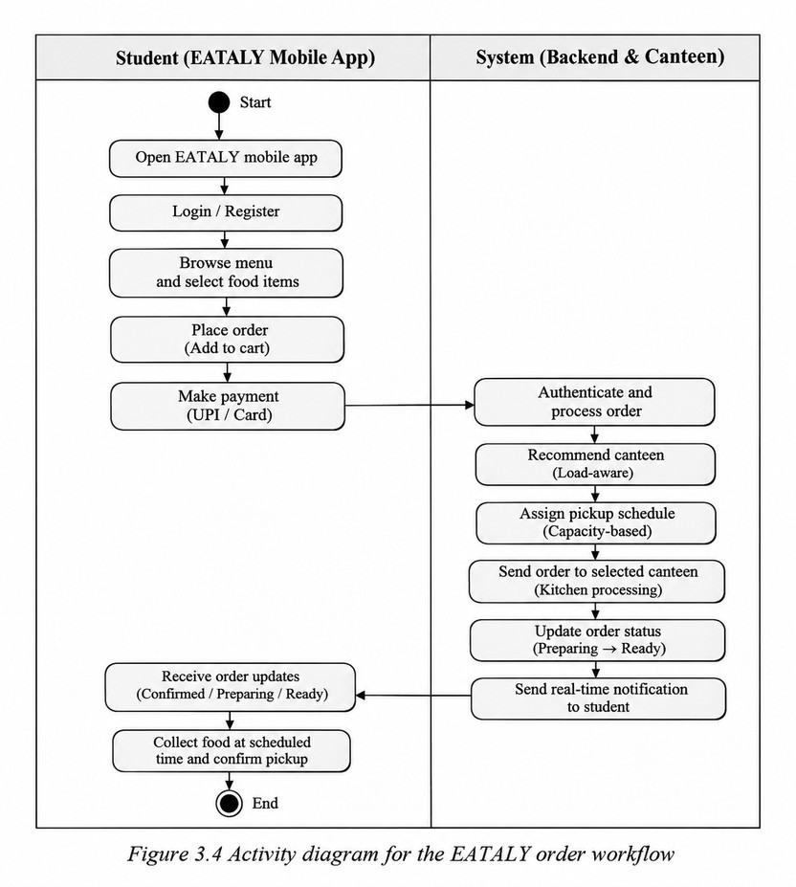

Sequence Diagram

A sequence diagram illustrates the exchange of information between system components in the order in which communication occurs. In EATALY, the participating components include the student mobile application, the cloud backend, the canteen management system, and the administrative dashboard. During a food ordering operation, the student logs into the application, selects food items, and submits an order along with the payment request. The backend authenticates the user,

processes the order, performs load-aware canteen recommendation and capacity-based pickup scheduling, and forwards the request to the selected canteen.

The canteen staff receives the order through the administrative dashboard and updates its status as preparation progresses. These updates are synchronized with the cloud database and delivered to the student's mobile application through real-time notifications. The sequence diagram demonstrates the communication flow among all system components, illustrating how information is exchanged from order placement and processing to final food collection while ensuring efficient coordination and timely service delivery.

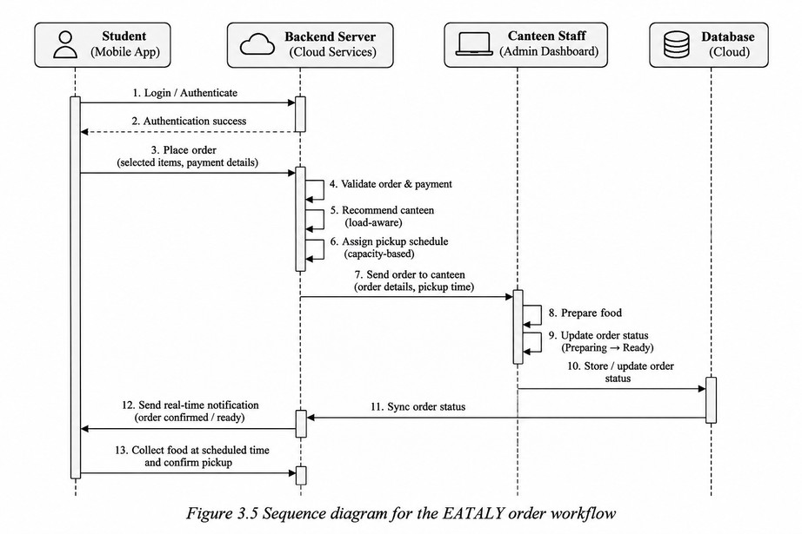

Cloud Communication and Data Flow

The EATALY system employs a cloud-based communication architecture to enable seamless data exchange between the student mobile application, the backend server, and the administrative dashboard. Whenever a user places an order, the application securely transmits the request to the cloud backend, where it is authenticated, processed, and stored in the centralized database. The backend coordinates communication among all system components while ensuring data consistency and real-time synchronization.

The cloud infrastructure manages order processing, menu updates, payment verification, load-aware canteen recommendation, and capacity-based pickup scheduling. Order status updates generated by canteen administrators are immediately synchronized with the database and delivered to students through real-time notifications. This centralized communication model enables efficient coordination among users, canteen staff, and administrators while supporting scalable deployment across multiple campus food outlets.
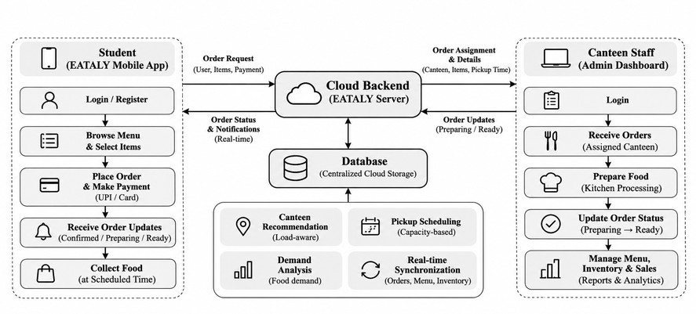

Figure 3.6 Data-flow diagram

Module Design

EATALY is organized into multiple functional modules, each responsible for a specific aspect of campus food management. The Student Module enables users to register, authenticate, browse menus, place food orders, complete digital payments, track order status, and receive real-time notifications. The Order Management Module processes incoming orders, validates transactions, performs load-aware canteen recommendation, and assigns capacity-based pickup schedules to ensure efficient order distribution across campus food outlets.

The Administration Module provides canteen staff with facilities to manage menus, receive and process orders, update preparation status, monitor inventory, and generate sales reports. The Analytics Module performs demand forecasting and operational analysis using historical ordering data to support inventory planning and decision-making. The modular architecture enables each component to operate independently while communicating through a centralized cloud backend, making the system scalable, maintainable, and adaptable to future enhancements such as AI-based recommendations and smart inventory management.

SOFTWARE IMPLEMENTATION

Software Architecture and Technology Stack

The software architecture of EATALY follows a cloud-based client–server model that integrates the student mobile application, administrative dashboard, centralized database, and backend services into a unified campus food management ecosystem. The mobile application enables students to browse menus, place food orders, complete secure digital payments, and receive real-time order updates. The administrative dashboard provides facilities for menu management, order processing, inventory monitoring, sales analysis, and operational reporting. The cloud backend coordinates communication between all system components while supporting intelligent features such as load-aware canteen recommendation, capacity-based pickup scheduling, and demand forecasting.

The system is developed using Flutter for cross-platform mobile application development, Firebase Authentication for secure user management, Cloud Firestore as the real-time database, and Firebase Cloud Messaging (FCM) for instant notifications. Backend services are implemented using Firebase Cloud Functions and integrated with payment gateways for secure transaction processing. The modular software architecture separates user interface, business logic, cloud services, and data management into independent components, improving maintainability, scalability, and enabling future enhancements without affecting existing system functionality.

Student Application Implementation

The EATALY student application provides a complete digital food-ordering experience through an intuitive mobile interface. Students can browse available campus canteens, view live crowd levels, estimated waiting times, and personalized recommendations before placing an order. The application also includes a campus crowd heatmap and an intelligent load-balancing feature that recommends alternative canteens with shorter queues to reduce waiting time.

After selecting menu items, students choose an available pickup slot and complete payment through the integrated wallet system. A digital token is generated for each order, allowing users to track preparation progress through multiple stages, modify or cancel eligible orders, and receive real-time status updates. This workflow minimizes physical queues while improving convenience and overall canteen efficiency.

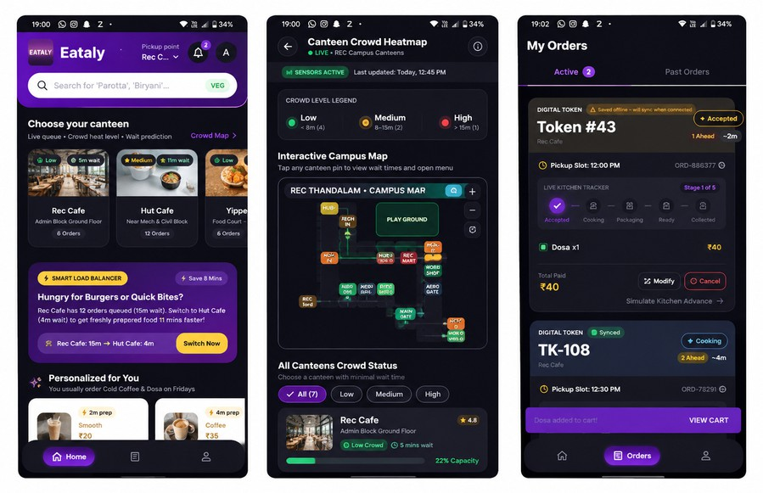
Figure 4.1 : EATALY student apllication home screen

Staff and Administration Portal

The EATALY Staff and Administration Portal provides a centralized platform for canteen operators and administrators to efficiently manage food preparation, order processing, and campus-wide distribution activities. Staff members securely authenticate using their institutional credentials and employee verification, ensuring that only authorized personnel can access the portal. The interface supports bilingual operation (English and Tamil), allowing staff to conveniently use the system in their preferred language. Live orders are categorized into different stages such as Pending, Preparing, Ready for Pickup, Completed, and Cancelled, enabling kitchen staff to monitor preparation progress and update order status in real time. Each order displays essential details including token number, pickup slot, ordered items, payment status, and customer information, ensuring accurate and organized order handling.
In addition to kitchen operations, the portal provides comprehensive live demand analytics to assist administrators in monitoring campus-wide food demand. Real-time dashboards display expected order volumes, high-demand periods, kitchen workload, and canteen capacity utilization. Administrators receive alerts during peak hours and can proactively manage crowd situations by monitoring predicted demand and identifying overloaded food counters. The system also supports inventory-aware menu management and enables staff to update food availability, helping maintain smooth kitchen operations while minimizing order delays.

The portal further includes a Distribution Hub Management module for coordinating campus-wide food delivery. Administrators can monitor multiple distribution hubs, view the number of available delivery personnel, assign runners to active orders, and track delivery progress in real time. Consolidated orders are grouped efficiently before dispatch, reducing unnecessary travel and improving delivery efficiency across campus. Together with live operational analytics, bilingual support, and real-time order tracking, the Staff and Administration Portal enables faster decision-making, balanced resource utilization, and efficient management of multiple campus canteens.

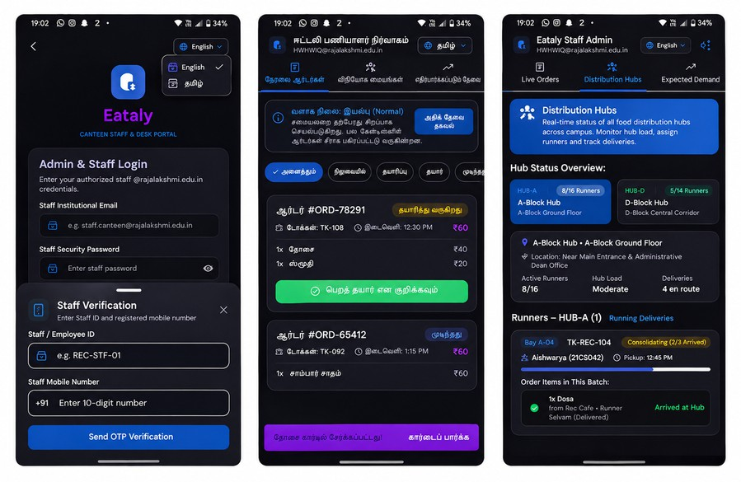
Figure 4.2 EATALY staff and administration portal with bilingual support (English and Tamil)

Smart Order Processing and Queue Management

EATALY incorporates an intelligent order processing system that minimizes waiting time through digital token generation, scheduled pickup slots, and real-time kitchen tracking. During checkout, students can select an available pickup slot based on current kitchen workload and order capacity. Once an order is confirmed, a unique digital token is generated, allowing users to monitor the preparation status without physically waiting in queues.

The system continuously tracks each order through multiple stages, including Accepted, Cooking, Packaging, Ready for Pickup, and Collected. Students receive live updates and notifications as their order progresses, while kitchen staff can update preparation status through the staff portal. The smart queue management mechanism distributes orders across available time slots, prevents overcrowding at pickup counters, and improves overall operational efficiency during peak campus hours.

Smart Load Balancing and Crowd Management

EATALY incorporates a smart load balancing mechanism to reduce waiting time and improve resource utilization across multiple campus canteens. The system continuously monitors live order queues, estimated preparation times, kitchen workload, and crowd density to identify overloaded food counters. Based on this information, students receive intelligent recommendations to switch to nearby canteens offering shorter waiting times for similar menu items, enabling faster service without compromising food availability.

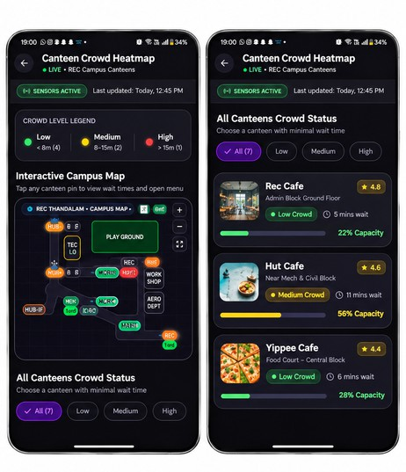
To further enhance crowd management, EATALY provides a live campus crowd heatmap displaying the occupancy and estimated waiting time of each canteen. Administrators can monitor peak demand periods, identify congestion hotspots, and take proactive measures such as informing staff, balancing workloads, or deploying additional delivery personnel. By combining real-time analytics with intelligent recommendations, the system minimizes queue congestion, improves order distribution, and delivers a smoother dining experience across the campus.

Figure 4.3 Smart Load Balancing and Crowd Management

Notification and Digital Token System

The EATALY application provides a digital token system that eliminates the need for students to wait in physical queues. After a successful order, the system generates a unique digital token along with the selected pickup slot. Students can track their order status through multiple stages, including Accepted, Cooking, Packaging, Ready for Pickup, and Collected, using the live kitchen tracker within the application.

The application also sends real-time notifications for important events such as order confirmation, preparation progress, pickup readiness, and order completion. These notifications keep users informed throughout the ordering process, reducing uncertainty and improving the overall dining experience while ensuring smooth coordination between students and canteen staff.

Payment and Pickup Slot Management

EATALY streamlines the ordering process through integrated digital payments and intelligent pickup slot scheduling. During checkout, students can choose from available pickup slots based on current kitchen workload and order capacity. The system prevents overbooking by limiting the number of orders assigned to each time slot, reducing congestion at the collection counter.

Once payment is successfully completed, a digital token is generated and linked to the selected pickup slot. Students can collect their food by presenting the token at the designated counter, ensuring faster service, reduced waiting time, and organized order distribution during peak campus hours.

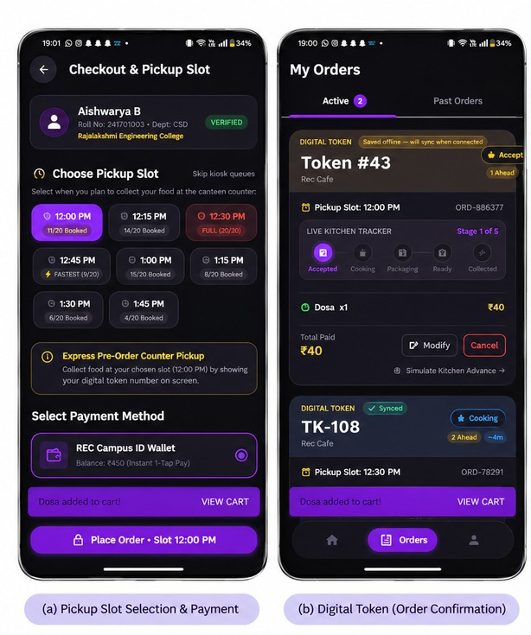
Figure 4.4 Payment and Pickup slot management

4.7 Real-Time Order Tracking

The application provides real-time order tracking, allowing students to monitor the progress of their orders from preparation to collection. Each order passes through multiple stages, including Accepted, Cooking, Packaging, Ready for Pickup, and Collected, with the current status displayed through a live progress tracker.

Kitchen staff update the order status through the staff portal, and the information is synchronized instantly with the student application. This real-time synchronization improves transparency, keeps users informed throughout the ordering process, and minimizes uncertainty regarding food preparation and pickup readiness.
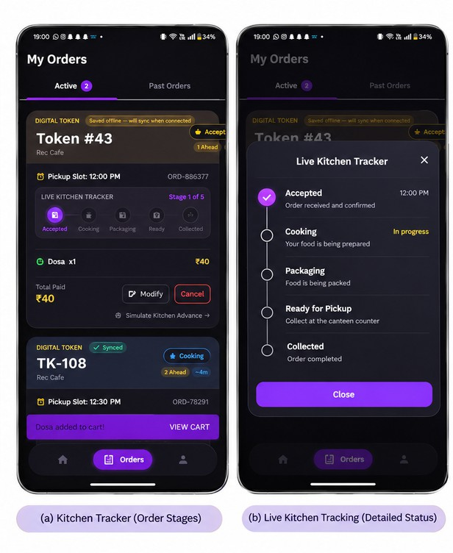
Figure 4.5 Real time order tracking

METHODOLOGY AND ALGORITHMS

Smart Food Ordering Workflow

EATALY automates the complete food ordering process across multiple campus canteens. When a student places an order, the application first retrieves live menu availability, crowd density, estimated waiting time, and available pickup slots from the backend server. After the student confirms the order and payment, the system generates a unique digital token and forwards the request to the selected canteen. Kitchen staff receive the order instantly through the Staff Portal and update its preparation status in real time. Every status change is synchronized with the student's application until the order is collected.

Algorithm 5.1: Smart Food Ordering

Input : Student request (canteen, food items, pickup slot) Output: Digital token and live order tracking

- Student logs into the application.
- Fetch available canteens and live queue data.
- Display menus and available pickup slots.
- Student selects items and confirms payment.
- Generate unique order ID and digital token.
- Send order to selected canteen.
- Kitchen updates status (Accepted → Preparing → Ready → Collected).
- Synchronize status with student application.
- End.

Smart Load Balancing Algorithm

The Smart Load Balancing module continuously analyzes the workload of every canteen by monitoring queue length, active orders, average preparation time, and

available kitchen capacity. Whenever a student selects a food item, the algorithm compares all canteens serving the same item and recommends the location with the shortest estimated waiting time. This distributes demand evenly across campus and minimizes congestion during peak hours.

Estimated Waiting Time
\[ WT = \frac{Q \times PT}{K} \] Where,
- WT = Estimated waiting time
- Q = Number of active orders
- PT = Average preparation time per order
- K = Number of active kitchen counters

Algorithm 5.2: Smart Load Balancer

Input : Food item selected by student Output: Best canteen recommendation

- Retrieve all canteens serving the selected item.
- For each canteen: Read queue length.
Read average preparation time. Read available kitchen counters. Calculate waiting time.
- Compare waiting times.
- Select canteen with minimum waiting time.
- If alternate canteen saves significant time, recommend switching.
- Display recommendation to the student.
- End.

Digital Token Generation and Queue Management

The Digital Token Management module ensures that every confirmed order is assigned a unique token number and an optimized pickup slot. The system validates slot availability before confirming the order and limits the number of orders accepted for each time interval. If a slot reaches its maximum capacity, the system automatically suggests the next available slot. This mechanism reduces long queues, prevents overcrowding at the pickup counter, and enables smooth order collection.

Algorithm 5.3: Digital Token Allocation

Input : Confirmed student order Output: Digital token and pickup slot

- Receive confirmed order.
- Check selected pickup slot availability.
- If slot has capacity, assign slot.
Else
suggest next available slot.
- Generate unique digital token.
- Store token in database.
- Send token to student application.
- End.

Live Crowd Prediction Algorithm

The Crowd Prediction module continuously monitors active orders, customer arrivals, kitchen workload, and historical demand patterns to estimate crowd density at each campus canteen. Based on the calculated waiting time, every canteen is classified as Low, Medium, or High crowd level. The prediction results are displayed through the live crowd map, helping students choose the least crowded canteen before placing an order.

\Crowd Level Classification

Crowd =
{
Low, WT < 8 min Medium, 8 ≤ WT < 15 min High, WT ≥ 15 min
}

Algorithm 5.4: Crowd Prediction

Input : Live order and queue data Output: Crowd level for each canteen

- Collect active orders.
- Calculate estimated waiting time.
- If waiting time < 8 min, mark Low.
- Else if waiting time < 15 min, mark Medium.
- Else
mark High.
- Update crowd map.
- Refresh periodically.
- End.

Personalized Food Recommendation Algorithm

The recommendation module analyzes a student's previous orders, favourite food items, ordering frequency, preferred canteens, and time of purchase. Based on this information, the system recommends relevant menu items that are currently available. Frequently ordered items and meals with shorter preparation times are given higher priority to improve user convenience.

Recommendation Score
\[ Score = (0.5 \times Frequency) + (0.3 \times Preference) + (0.2 \times Availability) \]

Algorithm 5.5: Personalized Recommendation

Input : Student order history Output: Recommended menu items

- Retrieve previous orders.
- Calculate ordering frequency.
- Check current menu availability.
- Compute recommendation score.
- Rank menu items.
- Display top recommendations.
- End.

TESTING AND RESULTS

Testing Strategy

Testing and evaluation were conducted to assess the functionality, reliability, and overall performance of the EATALY smart campus food management system. The evaluation focused on validating core features such as user authentication, menu browsing, smart load balancing, digital token generation, pickup slot allocation, crowd prediction, bilingual interface, and live order tracking. Both the Student Portal and Staff Portal were tested to ensure seamless communication and synchronization between users and canteen administrators.

Functional testing was performed for every module to verify that orders were correctly processed, digital tokens were generated without duplication, and real-time status updates were reflected accurately across both portals. The crowd prediction and smart load balancing features were evaluated using simulated peak-hour ordering scenarios to confirm that the system successfully recommended alternative canteens with lower waiting times. In addition, usability testing was conducted with multiple users to evaluate interface responsiveness, ease of navigation, and bilingual language support, ensuring a smooth user experience across different devices.

Experimental Setup

The experimental evaluation of EATALY was carried out using the developed Flutter mobile application, Firebase backend services, and the Staff Administration Portal. The system was deployed on Android smartphones connected to the same cloud database, enabling real-time synchronization between student users and canteen staff. Simulated order requests were generated from multiple student accounts while staff members processed these requests through the administration portal to evaluate live communication and system responsiveness.

Different testing scenarios, including normal operation, peak-hour demand, slot saturation, and simultaneous order placement, were executed to assess system performance. During each experiment, parameters such as order processing time, token generation accuracy, synchronization delay, crowd prediction updates, and smart load balancing recommendations were observed. The experimental results demonstrated that EATALY efficiently handled concurrent requests, maintained real-time order tracking, optimized canteen workload distribution, and significantly improved the campus food ordering experience through intelligent queue and crowd management.

Smart Canteen Testing Scenarios

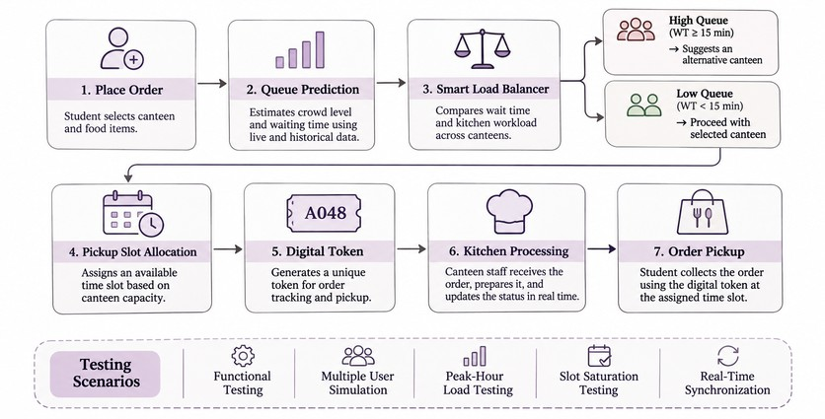
The EATALY system was evaluated using multiple real-world campus dining scenarios to verify the performance of its smart food ordering, crowd management, and staff coordination features. Testing covered student ordering, slot booking, kitchen workflow, live order tracking, bilingual interface switching, and staff dashboard operations under different demand conditions.Different crowd levels were simulated by varying the number of active users and orders across multiple campus canteens. The system monitored waiting times, kitchen workload, pickup slot availability, and order routing decisions. Live synchronization between the student application and staff portal was verified to ensure that every order status update was reflected instantly for both students and administrators.

Figure 6.1 EATALY testing and evaluation workflow

Functional Validation Procedure

Each major module of EATALY was validated independently before evaluating complete system integration. Student-side testing included menu browsing, smart canteen recommendations, pickup slot reservation, secure payment, digital token generation, and live kitchen progress tracking. Staff-side validation focused on order acceptance, preparation management, bilingual interface support, workload monitoring, distribution hub coordination, and live demand analytics.

The crowd management module was tested by generating varying campus traffic conditions and verifying crowd classification, waiting time estimation, and alternative canteen recommendations. The Smart Load Balancer was validated by ensuring that users were redirected only when another nearby canteen offered significantly lower waiting time while maintaining kitchen workload balance.

Overall system testing confirmed accurate synchronization between all application modules, smooth real-time communication between student and staff portals, reliable order processing, and consistent performance across normal and peak-hour operating conditions.

Comparative Performance Analysis

The performance of the proposed EATALY system was evaluated by comparing conventional canteen operations with the smart queue management approach implemented in the application. The evaluation considered key operational parameters such as average waiting time, queue distribution, order processing efficiency, pickup slot utilization, and successful order completion during both normal and peak-hour scenarios. Testing was performed using multiple simulated users and real-time order updates to analyze system responsiveness under varying workloads.

The experimental results demonstrated that the smart load balancing module effectively redistributed users from highly congested canteens to nearby alternatives with lower waiting times, reducing queue concentration during peak periods. The pickup slot allocation mechanism prevented overcrowding at service counters by evenly distributing collection timings, while the digital token system provided accurate real-time order tracking and minimized manual verification. The bilingual interface further improved usability for both students and staff, ensuring consistent interaction across English and Tamil users.
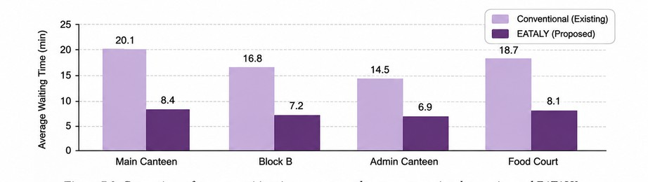
Figure 6.2 Comparison of average waiting time per canteen between conventional operation and EATALY
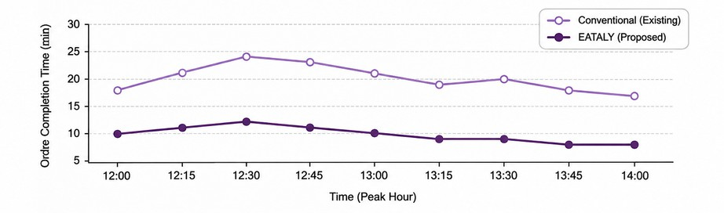
Figure 6.3 Order Completion during peak hours

Overall, the proposed EATALY framework showed significant improvements in operational efficiency, faster order processing, balanced kitchen workload, and enhanced user experience compared to conventional first-come-first-served canteen management. These results indicate that integrating predictive queue analytics, intelligent load balancing, and digital order management can substantially improve food service operations within a university campus.

Repeatability Observations

Repeatability was evaluated by executing identical test scenarios multiple times under the same operating conditions. The system consistently generated similar waiting-time estimates, crowd-density predictions, and smart load-balancing decisions, with only minor variations caused by changes in user requests and queue status. These observations indicate that the proposed algorithms provide stable and reliable outputs for real-time cafeteria operations.

Functional and Integration Testing

Functional testing verified all major EATALY modules, including menu browsing, authentication, order placement, payment processing, smart load balancing, crowd visualization, digital token generation, pickup slot booking, and bilingual staff management. Integration testing confirmed seamless communication between the mobile application, Firebase backend, recommendation engine, and notification service, ensuring accurate real-time synchronization across all components.

Limitations and Discussion

The prototype was evaluated using simulated cafeteria data and controlled testing scenarios. Although the proposed algorithms demonstrated effective queue balancing and crowd prediction, real-world performance may vary with changing user behaviour, network conditions, and peak-hour demand. Future work includes large-scale deployment, machine learning–based demand forecasting, and integration with IoT sensors for more accurate occupancy estimation.

CONCLUSION AND FUTURE SCOPE

Conclusion

EATALY successfully demonstrates the development of a smart canteen management system that integrates mobile technology, cloud computing, and intelligent scheduling algorithms to improve the overall food ordering experience. The system combines a Flutter-based mobile application with Firebase services to provide real-time order processing, secure authentication, cloud synchronization, and digital token management. Features such as smart load balancing, crowd heatmap visualization, pickup slot booking, bilingual staff management, and instant notifications help reduce waiting time, optimize queue distribution, and improve operational efficiency. Experimental testing confirmed that the proposed system performs reliably under different ordering scenarios, providing a scalable, user-friendly, and efficient solution for modern educational institutions and workplace cafeterias.

Project Achievements

The major achievement of EATALY is the successful integration of intelligent queue management and real-time cloud-based services into a single mobile platform. The application supports secure user authentication, menu browsing, online ordering, digital token generation, smart load balancing, crowd visualization, pickup slot scheduling, multilingual staff communication, and real-time notifications through Firebase. The proposed algorithms effectively distribute customer traffic across available counters, reducing congestion and improving service efficiency. Performance testing demonstrated reliable synchronization between the mobile application and cloud database, validating the practicality of the system for handling day-to-day cafeteria operations. The modular architecture also provides flexibility for future enhancements, including AI-based demand prediction, IoT integration, and advanced analytics for canteen management.

Current Limitations

Although EATALY functions as a fully operational prototype, its evaluation was conducted primarily using simulated cafeteria data and controlled testing environments. The performance of features such as smart load balancing and crowd prediction depends on the accuracy of real-time user activity and order information. Network latency, internet connectivity, and sudden surges in customer demand may influence synchronization and response time during peak hours. Furthermore, the current implementation does not incorporate IoT-based occupancy sensors or advanced AI models for demand forecasting, limiting the precision of crowd estimation in highly dynamic environments. Additional large-scale deployment across multiple cafeterias is required to comprehensively evaluate system scalability, reliability, and long-term performance.

Future Enhancements

Future development of EATALY can focus on improving intelligence, scalability, and user convenience. Machine learning models can be integrated to predict food demand, optimize inventory management, and provide personalized meal recommendations based on user preferences. IoT-based occupancy sensors and computer vision techniques can further enhance crowd estimation and improve the accuracy of smart load balancing. The application can also support multiple campus cafeterias, digital wallet integration, loyalty and reward programs, nutritional analysis, and voice-assisted ordering. Administrative dashboards with advanced analytics and reporting can assist canteen managers in monitoring sales, peak-hour trends, and operational efficiency. These enhancements would transform EATALY into a comprehensive smart cafeteria management platform suitable for educational institutions, corporate campuses, and large-scale food service environments.

REFERENCES

- A. Google, Flutter Documentation, Google Developers, 2026. Available: https://docs.flutter.dev/

- A. Google, Firebase Documentation, Google Developers, 2026. Available: https://firebase.google.com/docs

- Google Cloud, Cloud Firestore Documentation, 2026. Available: https://firebase.google.com/docs/firestore

- M. Fowler, Patterns of Enterprise Application Architecture. Boston, MA, USA: Addison-Wesley, 2002.

- I. Sommerville, Software Engineering, 10th ed. Pearson Education, 2016.

- H. M. Deitel and P. J. Deitel, Android 6 for Programmers: An App-Driven Approach. Pearson, 2016.

- G. Coulouris, J. Dollimore, T. Kindberg, and G. Blair, Distributed Systems: Concepts and Design, 5th ed. Pearson Education, 2012.

- T. H. Cormen, C. E. Leiserson, R. L. Rivest, and C. Stein, Introduction to Algorithms, 4th ed. MIT Press, 2022.

- J. Nielsen, Usability Engineering. Morgan Kaufmann Publishers, 1994.

